RESCHEDULED

CITY OF CHILLIWACK

NOTICE OF RESCHEDULED PUBLIC HEARING
Tuesday, December 3, 2019 at 7:00 pm
Council Chambers
8550 Young Road, Chilliwack, BC V2P 8A4
www.chilliwack.com

TAKE NOTICE that the Council of the City of Chilliwack will hold a Public Hearing, as noted above, on the following item:

- ZONING BYLAW AMENDMENT BYLAW 2019, No. 4760 (RZ001361)

Location: 104 - 5625 Promontory Road (a portion of)

Applicant: 1196774 BC Ltd.

Purpose: To rezone a portion of the subject property, as shown on the map below, from a C2 (Local Commercial) Zone to a C9 (Cannabis Retail) Zone to permit the operation of a retail cannabis store.

Location Map

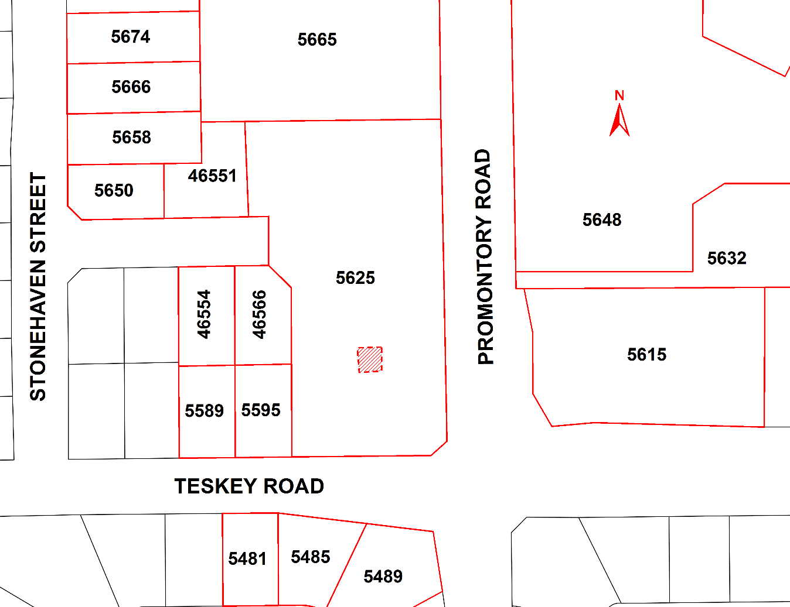

Persons who deem that their interest in the property is affected by the proposed amendment bylaw will have an opportunity to be heard at the Public Hearing or, if you are unable to attend, you may provide a written submission, including your full name and address, to the Corporate Services Department at 8550 Young Road, Chilliwack, BC, V2P 8A4 or by email to clerks@chilliwack.com no later than 4:00 pm on the date of the Public Hearing. All submissions will be recorded and form part of the official record of the Hearing.

The proposed bylaw may be inspected between the hours of 8:30 am and 4:30 pm, Monday through Friday, excluding holidays, from Wednesday, November 20, 2019 to Tuesday, December 3, 2019, both inclusive, in the Corporate Services Department at City Hall, 8550 Young Road, Chilliwack, BC. Please direct your enquiries to our Planning & Strategic Initiatives Department at 604-793-2906.

Please note that no further information or submissions can be considered by Council after the conclusion of the Public Hearing.

Jacqueline Morgan, CMC
Corporate Officer

